UNIT 1 — OPERATING SYSTEM ARCHITECTURE

1.3 Operating System Structures and Kernel Types

Topics
- Monolithic Kernel
- Microkernel
- Hybrid Kernel
- Layered Kernel
- Exokernel
- Modular Kernel
- Comparison of all kernel structures
- Kernel selection for an Embedded Real-Time System

- “Compare and contrast monolithic, microkernel, and hybrid kernel architectures. Discuss the advantages and disadvantages of each type. Provide examples of operating systems that use these kernel types and explain why they are suitable for their respective use cases.”

Introduction
A kernel architecture defines how an operating system organizes and manages its core services. The main types are monolithic, microkernel, and hybrid kernels, each differing in performance, security, reliability, and modularity.

1. MONOLITHIC KERNEL
A monolithic kernel is a large kernel architecture in which all major operating system services such as
- Process management
- Memory management
- Inter-process communication (IPC)
- System call handling
- Device drivers
- File systems
- Networking
run in kernel mode with full privileges

Working
- A user application requests an operating system service.
- The application executes a trap (software interrupt).
- Hardware saves the user state and changes the CPU from user mode to kernel mode.
- Control is transferred to the kernel dispatcher.
- The dispatcher obtains parameters and uses the system call number to index the system call table.
- The corresponding service procedure executes.
- After completion, return-from-trap restores the previous process state.
- Execution continues in user mode.

Advantages
- High Performance: Direct communication provides fast execution.
- Simple Communication: No message passing overhead
- Good I/O Performance: Direct hardware access improves I/O speed.

Disadvantages
- Low Reliability: A faulty component can crash the entire system.
- Poor Maintainability: Tightly coupled code is difficult to modify and debug.
- Security Risk: A vulnerable component can affect the entire kernel.

Examples
- Linux
- UNIX
- MS-DOS
- CP/M
- Solaris
- BSDs
- OpenVMS

Suitable Use Cases
- General-purpose desktop computers
- Enterprise high-performance servers
- Supercomputers
- Systems where performance optimization is required.

2. Microkernel

Concept
A microkernel keeps only the essential OS functions such as
- Basic memory management
- Inter-process communication (IPC)
- CPU scheduling
- Low-level hardware handling
in kernel mode, while Other services such as
- device drivers,
- file systems, and
- networking
run in user space as separate servers.

Advantages
- High Reliability: A failed service usually does not crash the entire OS.
- High Security: Services are isolated with limited privileges.
- Fault Tolerance: Failed services can often be restarted independently.

Disadvantages
- Performance Overhead: Message passing and context switching can reduce performance.
- Complex Design: Managing communication between services is complex.

Examples
- MINIX 3
- QNX
- Mach
- L4

Suitable Use Cases
Microkernels are suitable for
- automotive,
- aerospace,
- industrial,
- Real-time,
- embedded,
and other systems where reliability and security are more important than maximum performance.

3. Hybrid Kernel
A hybrid kernel combines
- monolithic performance with
- microkernel modularity and stability.
Some services run in kernel mode, while others run in user mode.

Advantages
- Balanced Performance: Good performance with modularity.
- Good Modularity: Separates services with less overhead.
- Flexibility: Supports different system services and components.

Disadvantages
- Complex Design: Difficult to design and maintain.
- Large Kernel: Many services may run in kernel mode.
- Security/Reliability Risk: A faulty kernel component can affect the whole system.

Examples
- Windows NT / Windows 10/11
- macOS and iOS (XNU)
- ReactOS

Suitable Use Cases
Hybrid kernels are suitable for
- desktop computers,
- enterprise systems,
- gaming systems,
- workstations
Systems where high performance and modularity are required.
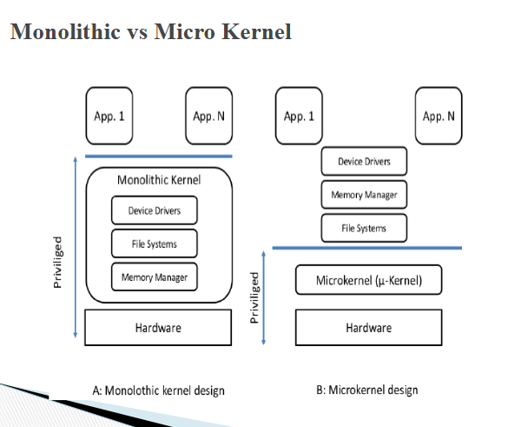

Conclusion
Monolithic kernels offer high performance, microkernels provide better security and reliability, while hybrid kernels balance performance and modularity.

